**Task 7: Install docker on EC2 and explore the docker commands (docker images, containers, volumes, network)**

**Install docker on ec2:**

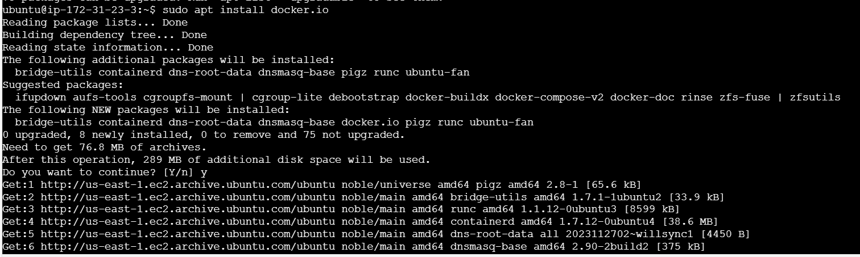

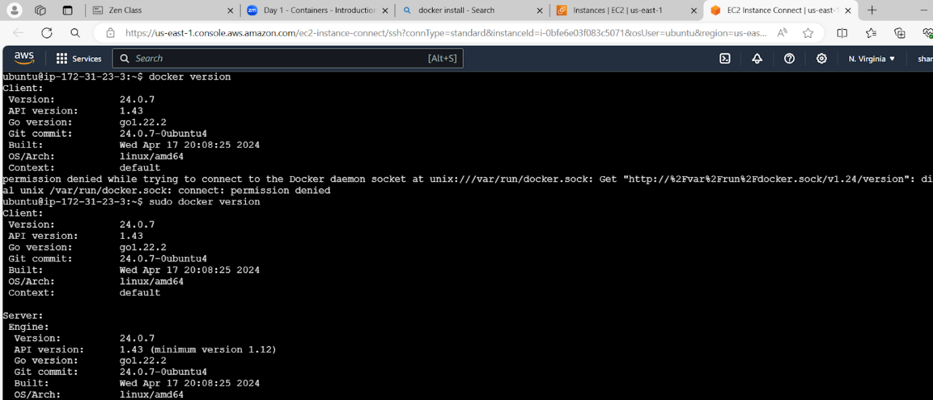

**Docker images:**

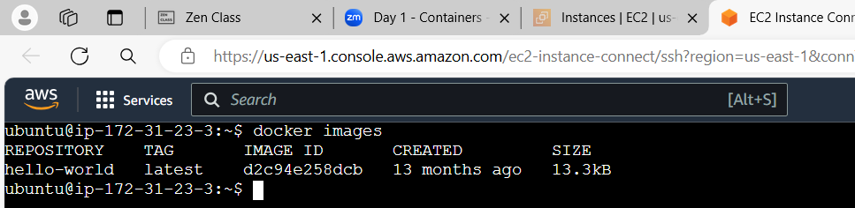

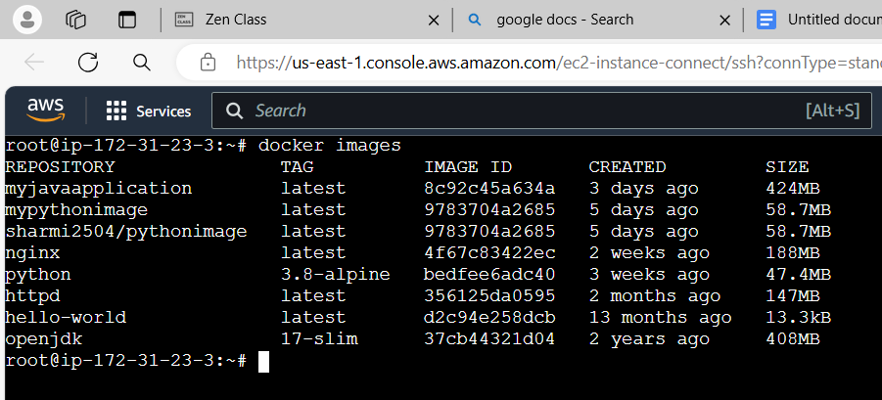

**Docker containers:**

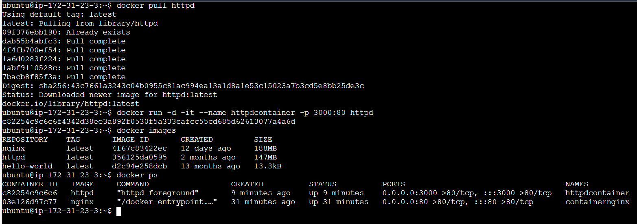

Copy ec2 ip address : 3000 port in web browser. Application works in port no: 3000

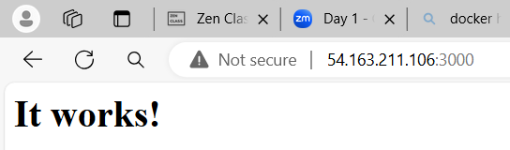

**Docker volume:**

**1.Create volume:**

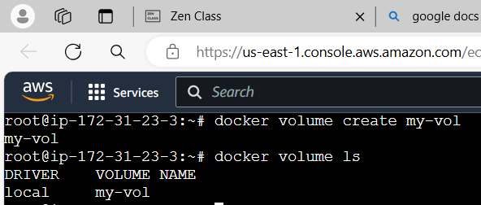

**2. Attach that volume in container:**

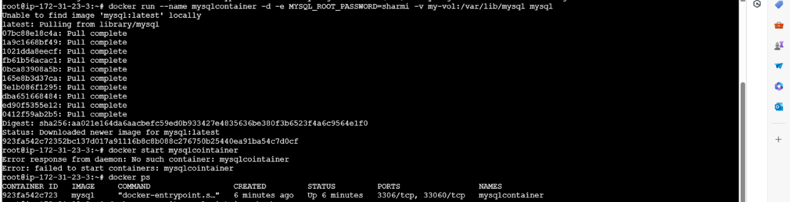

**3. add some data in volume:**

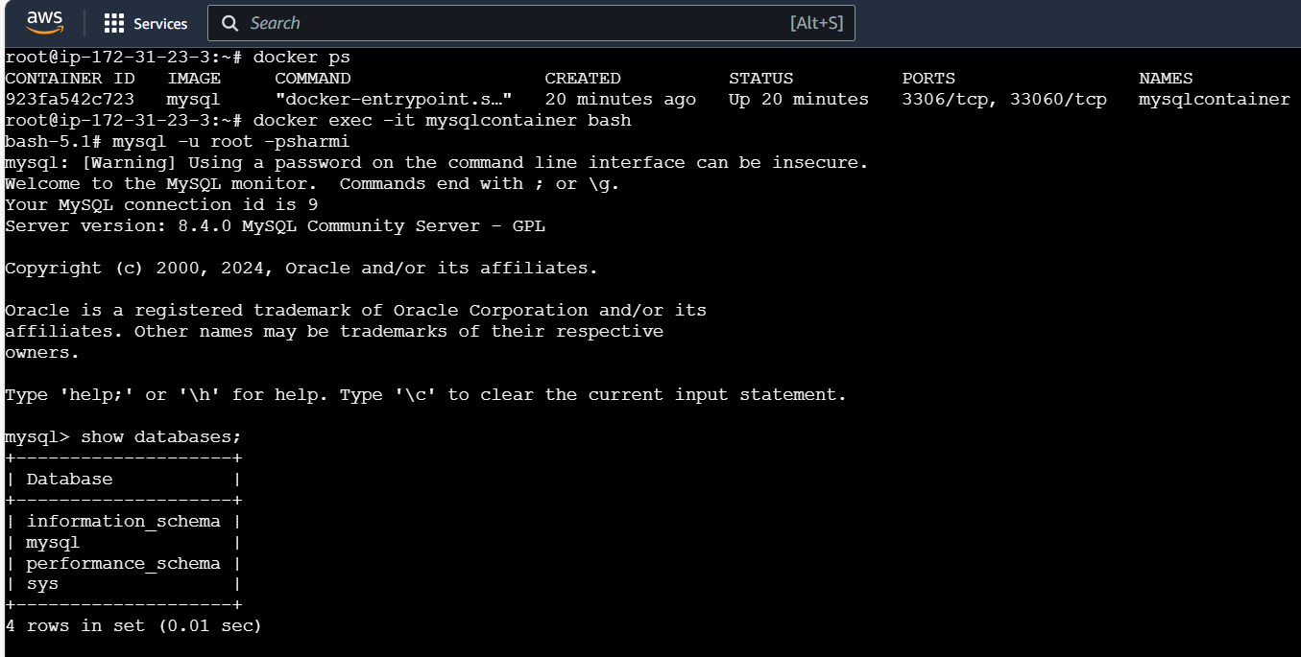

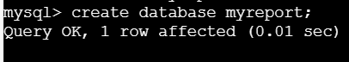

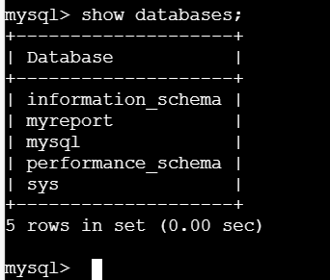

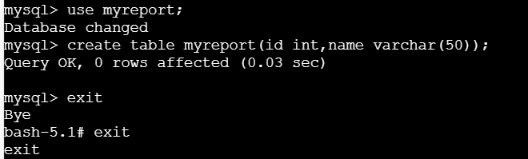

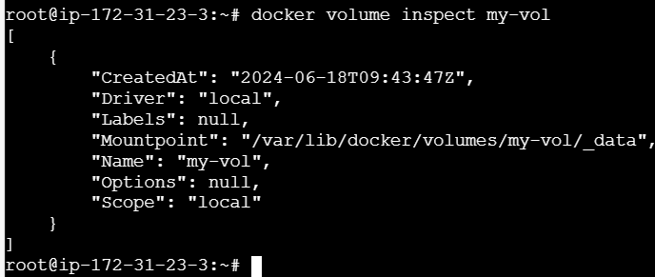

**4. Details for my data created inside volume:**

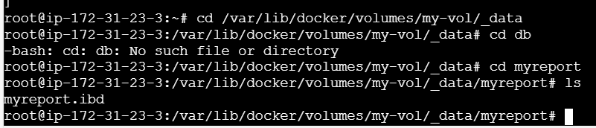

**Docker network:**

